Introduction:
In this lab, the goal was to set up BurpSuite, a powerful web vulnerability scanner, and utilize it to perform scans, enumeration, and exploits on a web application. The lab focused on using BurpSuite to interact with the OWASP Juice Shop application in a Docker container. The primary objectives were to understand BurpSuite's functionality and become familiar with its various tabs and tools.

Docker Setup:
Verified Docker Installation:
  - Opened a terminal on the Kali machine.
  - Checked Docker was installed using the command docker -v

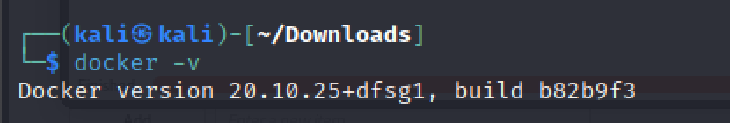

Pulled OWASP Juice Shop Docker Image:
- Pulled the OWASP Juice Shop Docker image using sudo docker pull bkimminich/juice-shop

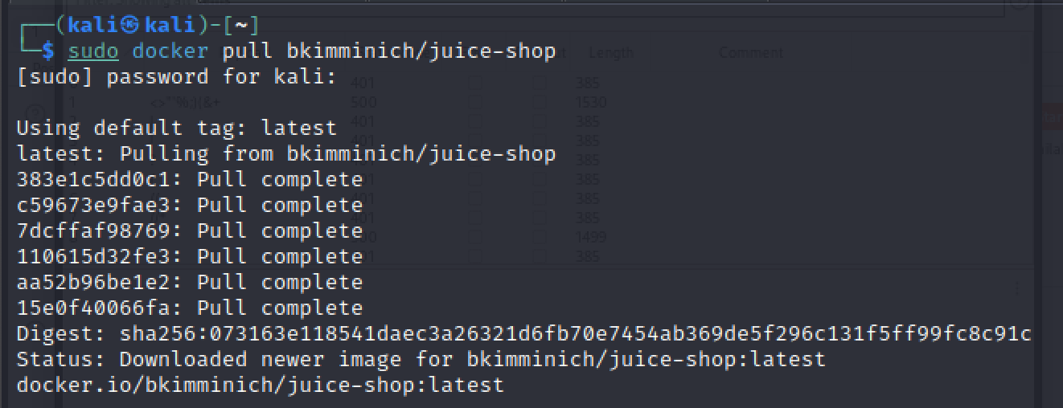

Ran OWASP Juice Shop:
- Launched the OWASP Juice Shop container using sudo docker run --rm -p 3000:3000 bkimminich/juice-shop

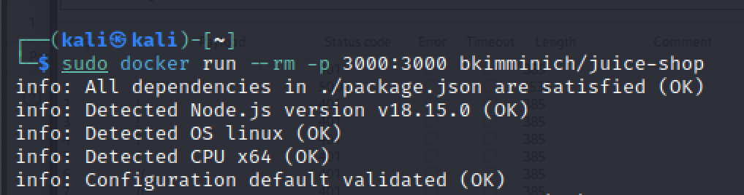

Exploring BurpSuite:
Request Examination:
  - Examined incoming and outgoing HTTP requests in the Proxy tab.
  - Observed request details and parameters.

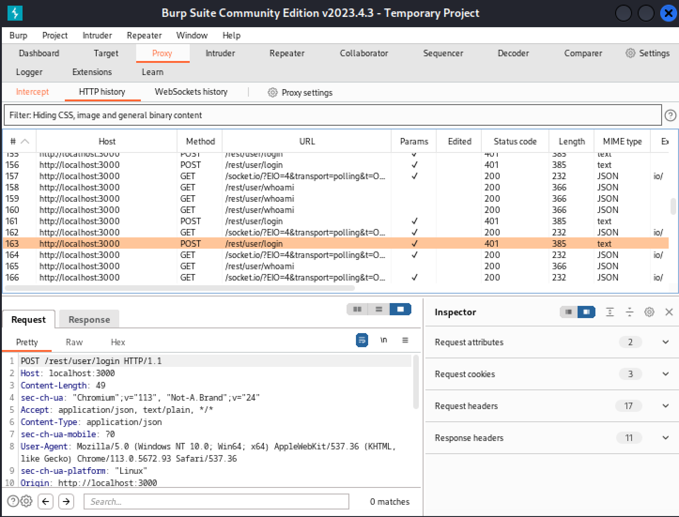

Repeater Tool:
- Explored the Repeater tool in Burp Suite.
- Used it to manually send and modify HTTP requests.

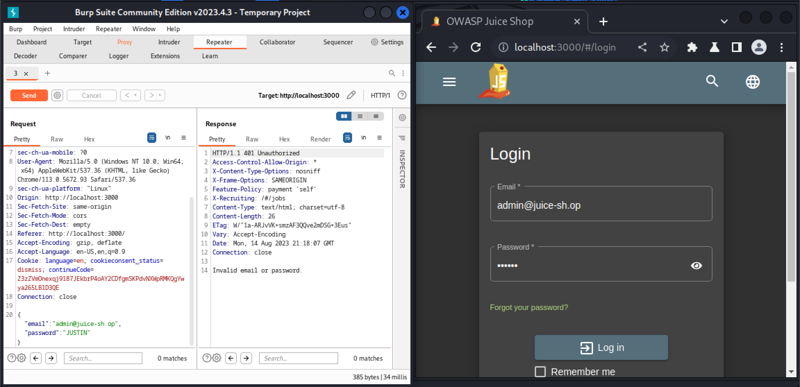

Web Application Testing:
SQL Injection Test:
  - Attempted an attack on the Juice Shop's login page to detect SQL Injection vulnerabilities.
  - Used provided text file (xplatform.txt) as a payload.
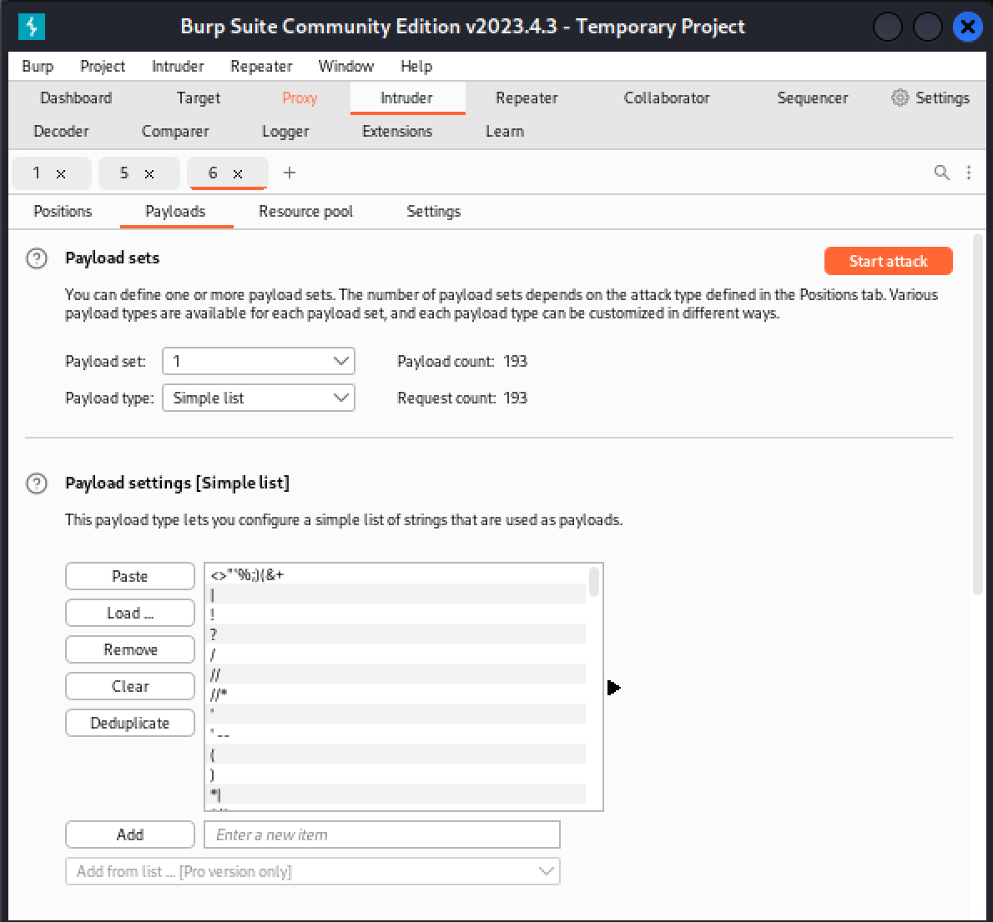
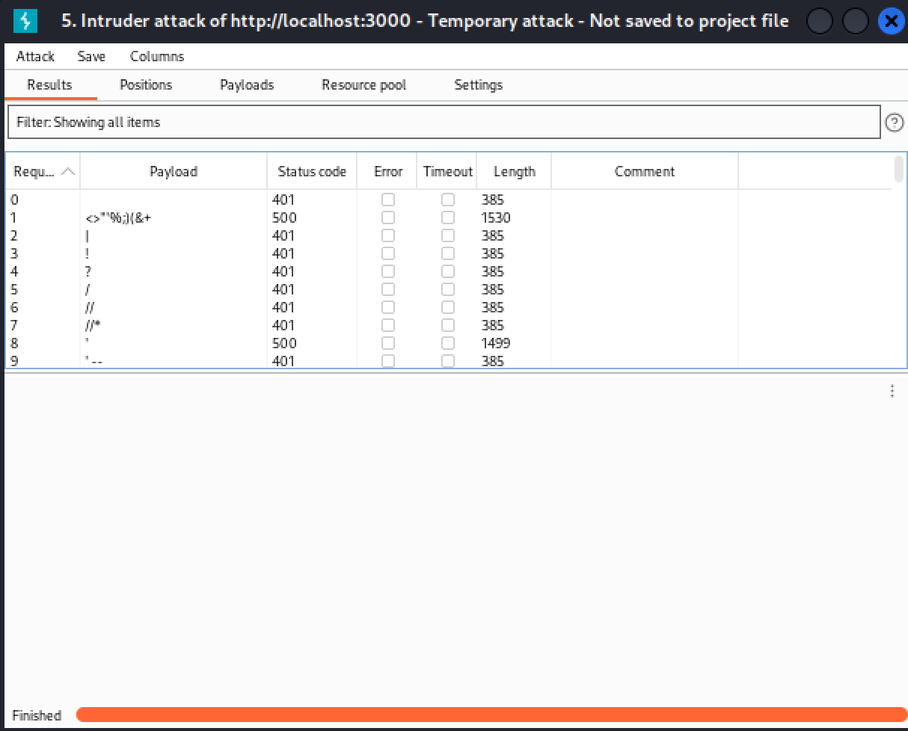
Findings:
During the lab, several observations were made:
- The Docker setup allowed for easy deployment and testing of the OWASP Juice Shop.
- BurpSuite's Proxy tab provided insight into HTTP requests and responses. You can selectively intercept and modify requests and responses by using the "Intercept" tab. Right-click on a request or response, and choose options like "Forward," "Drop," or "Action" to modify or manipulate the traffic.
- The Repeater tool proved useful for manually sending and altering requests. In the "Repeater" tab, you'll see the intercepted request in its raw format, including the HTTP method, URL, headers, and body.
- The attempted SQL injection test was unsuccessful, suggesting that the Juice Shop might be resilient to this specific vulnerability.

Conclusion:
In conclusion, the lab provided valuable hands-on experience with Burp Suite and its capabilities in web application security testing. The setup and testing procedures demonstrated the importance of tools like Burp Suite in identifying potential vulnerabilities within web applications.

